Measurement of Background Radiation at some Mechanical Workshop within Zaria Metropolis, Kaduna State, Nigeria

¹Tijjani F. S. ¹Garba, N.N., ¹Kankara. U. M., ¹Musa. J., ¹Vatsa, M.A., and ^{1,2}Bello, I.A.,
¹Department of Physics, Ahmadu Bello University, Zaria, Nigeria
²Division of Agricultural Colleges, Ahmadu Bello University, Zaria, Nigeria

Corresponding author:shehufatimatijjani663@gmail.com, +2347046301765

ABSTRACT
This study evaluated ionizing radiation dose rates and corresponding annual effective dose (AED) levels across fifteen automobile mechanical workshops in Zaria, North-Central Nigeria. Radiation measurements were conducted using a handheld survey meter, with dose rate values ranging from 0.12 to 0.20 µSv/h. These translate into AEDs between 0.210 and 0.350 mSv/yr, with the lowest recorded at DMG, AYSG, ABEG, GMG, and OBG (0.210 mSv/yr), and the highest at AIG (0.350 mSv/yr). Comparative assessment with related studies from different regions of Nigeria indicates consistency with typical outdoor background radiation levels, all remaining well below the International Commission on Radiological Protection (ICRP) recommended public exposure limit of 1.0 mSv/yr. The relatively uniform exposure across most workshops suggests minimal radiological health risks. However, slight variations observed may be attributed to environmental factors, soil composition, and workshop activities. These findings highlight the importance of continuous monitoring for occupational safety and effective radiation protection practices.
Keywords: background radiation, annual effective dose, Automobile mechanical workshops, Radiation monitoring.

1.0 INTRODUCTION
Radiation is globally recognized for its potential harmful effects on human health, and Nigeria is not exempt from such concerns (Oyeyinka et al., 2012; Ford, 2004). Human beings are exposed to radiation from both natural and artificial sources. Natural sources include primordial radionuclides such as uranium ²³⁸U, thorium ²³²Th, and potassium ⁴⁰K, while artificial radionuclides such as cesium ¹³⁷Cs and strontium ⁹⁰Sr originate from anthropogenic activities including industrial processes and nuclear technology (Avwiri et al., 2010). Unlike non-ionizing forms of environmental radiation such as heat, ionizing radiation has sufficient energy to ionize atoms and molecules, potentially causing DNA damage and cellular dysfunction (Haider & Mahmood, 2015; Turner, 2007). The extent of injury depends on radiation type (α, β, γ), energy, dose, exposure time, and the degree of shielding (ICRP, 1991).
Although the biological risks associated with low-level radiation remain an area of scientific debate, exposure is inevitable through cosmic rays, terrestrial radiation, medical applications, and radionuclides within food and air such as ³H, ¹⁴C, and ⁴⁰K (Oyeyinka et al., 2012). Regional variations in background radiation levels are largely influenced by geological and geographical settings (UNSCEAR, 2000; Tchokossa et al., 2012). Given the strong association between radiation exposure and cancer risk, systematic monitoring of environmental radiation is a crucial component of public health protection (MDH, 2008).
Several Nigerian studies have provided insight into environmental radiation levels. Ukokeno et al. (2024) reported elevated dose rates in scrap sites, automobile workshops, and wood workshops in Delta State. Olaoye (2023) showed radionuclide accumulation in soils around mechanic workshops, indicating potential long-term hazards. Ezemba et al. (2025) measured absorbed dose rates in Anambra South, with annual effective doses within global safety limits. Ofomola (2023) highlighted geological influence in a southeastern quarry, while Ugwuanyi et al. (2022) reported variations in background radiation between industrial buildings. A review by Samaila et al. (2022) identified research gaps in occupational settings such as workshops and scrap yards.
Despite their importance, mechanical workshops have received limited attention in radiological studies. These environments frequently involve the use of recycled metals that may harbor radionuclides (Lenka & Peter, 2010). In Zaria metropolis, Kaduna State, automobile repair, welding, and metal recycling are prevalent. This study therefore aims to measure background radiation levels in selected workshops, estimate annual effective doses, and compare results with international standards to evaluate occupational and public health risks.

2.0 MATERIALS AND METHODS

2.1 Study Area
This study was conducted within Zaria Metropolis, Kaduna State, Northwestern Nigeria, situated between latitude 11°04′N–11°12′N and longitude 7°41′E–7°46′E, with an estimated population of over one million people (NPC, 2006). Zaria is a major educational and commercial hub, hosting Ahmadu Bello University, several industries, and numerous mechanical workshops where automobile repairs, welding, and scrap recycling activities are common. These workshops were chosen because they represent potential hotspots for natural and anthropogenic radiation exposure due to the use of recycled metallic materials and possible contamination from industrial waste (Bello et al., 2021; Usman et al., 2021).

2.1 Selection of Sampling Locations
A purposive sampling strategy was employed to ensure spatial representation of some districts within the metropolis. Fifteen (15) mechanical workshops were selected across Dan-Magaji and Tukur-Tukur, based on their accessibility, activity level, and proximity to residential areas. Background control measurements were taken at a residential location with minimal industrial activity, to serve as a baseline (Orosun et al., 2021).

2.2 Instrumentation and Measurement protocol
The RDS-120 radiation survey meter was employed to measure background radiation. The detector was positioned one meter above ground level, set to its most sensitive scale, and held steady for five minutes. Measurements were recorded for each location. The collected dose rate values were later used to compute the annual effective dose rate in milli-sieverts per year (mSv/yr) using the established conversion formula (Tayyeb et al., 2012).

2.3 Annual effective dose rate
Annual effective dose rate (mSv/yr.) = EDR (µSv/h) × 0.2 × 8760h/yr. × 10⁻³ (1)
Where EDR denotes the equivalent dose rate. For public exposure assessment, an outdoor occupancy factor was applied. A total of 8,760 hours per year (24 hours × 365 days) was considered, with an outdoor occupancy fraction of 0.2, since the study was conducted in open workshop environments (Bello et al., 2021)

2.4 Garmin Handheld GPS-12
To operate the Garmin Handheld GPS-12, the device was held one meter above ground level and powered on by pressing the power button, allowing it to self-test and acquire satellite signals until the positioning page appeared. The “Mark” key was then pressed to record the current position as a waypoint. After shifting the device for a few minutes in any direction, the “Page” button was pressed to display the compass page, and the readings were recorded.

3.0 RESULTS AND DISCUSSION
Table 1 presents the mean dose levels recorded at different automobile mechanical workshops within Zaria metropolis, Kaduna State. A total of fifteen (15) measurements were conducted using the RDS-120 survey meter (Plate 3.1) to obtain dose rates in µSv/h, while the Garmin GPS-12 meter (Plate 3.2) was employed to determine the geographical coordinates of each location. For clarity, only the mean dose rates are reported in Table 1, and the corresponding annual effective dose rates were subsequently calculated using Equation 1, with results presented in Table 2 below.
Table 1: Mean dose level of different automobile mechanical workshop locations
S/N | LOCATION | LONGITUDE AND LATITUDE (N & E) | MEAN DOSE RATE (µSv/h)
1 | D M G | 11º05´20.3´´N, 007º41´20.7´´E | 0.12
2 | A Y S G | 11º05´22.0´´N, 007º41´19.9´´E | 0.12
3 | O Y G | 11º05´24.1´´N, 007º41´21.2´´E | 0.18
4 | A B E G | 11º05´20.4´´N, 007º41´20.0´´E | 0.12
5 | A N G | 11º05´26.3´´N, 007º41´20.9´´E | 0.17
6 | O Z G | 11º05´27.4´´N, 007º41´21.3´´E | 0.17
7 | O N G | 11º05´27.0´´N, 007º41´22.1´´E | 0.17
8 | A I G | 11º05´21.1´´N, 007º41´21.5´´E | 0.20
9 | A U G | 11º05´21.4´´N, 007º41´20.8´´E | 0.13
10 | A D R G | 11º05´28.1´´N, 007º41´21.8´´E | 0.14
11 | A T G | 11º05´26.0´´N, 007º41´22.0´´E | 0.14
12 | O M G | 11º05´21.0´´N, 007º41´20.4´´E | 0.13
13 | G M G | 11º05´26.6´´N, 007º41´22.8´´E | 0.12
14 | R R G | 11º05´28.4´´N, 007º41´21.5´´E | 0.13
15 | O B G | 11º05´26.6´´N, 007º41´22.2´´E | 0.12

Table 1 presents the mean dose rates of ionizing radiation measured across fifteen automobile mechanical workshop locations in Zaria metropolis. The recorded values range from 0.12 µSv/h to 0.20 µSv/h, with the lowest at DMG, AYSG, ABEG, GMG, and OBG (0.12 µSv/h), and the highest at AIG (0.20 µSv/h). Most sites fall within 0.12–0.17 µSv/h, indicating relatively uniform radiation distribution with minor variations attributable to workshop activities, materials, or underlying soil composition. Notably, all measured values are below the global average outdoor background radiation level (~0.27 µSv/h), suggesting no significant radiological health risks in the investigated areas.

Table2: Total Effective dose rate of different automobile mechanical workshop
S/N | LOCATION | MEAN DOSE RATE (µSv/h) | AED (mSv/yr)
1 | D M G | 0.12 | 0.210
2 | A Y S G | 0.12 | 0.210
3 | O Y G | 0.18 | 0.315
4 | A B E G | 0.12 | 0.210
5 | A N G | 0.17 | 0.298
6 | O Z G | 0.17 | 0.298
7 | O N G | 0.17 | 0.298
8 | A I G | 0.20 | 0.350
9 | A U G | 0.13 | 0.228
10 | A D R G | 0.14 | 0.245
11 | A T G | 0.14 | 0.245
12 | O M G | 0.13 | 0.228
13 | G M G | 0.12 | 0.210
14 | R R G | 0.13 | 0.228
15 | O B G | 0.12 | 0.210

Table 2 illustrates the total effective dose rate of radiation exposure across fifteen automobile mechanical workshop locations, expressed as Annual Effective Dose (AED). The mean dose rates range from 0.12 to 0.20 µSv/h, translating into AED values between 0.210 and 0.350 mSv/yr. The lowest AED (0.210 mSv/yr) was recorded at DMG, AYSG, ABEG, GMG, and OBG, while the highest occurred at AIG (0.350 mSv/yr). Intermediate values such as 0.298 mSv/yr (ANG, OZG, ONG) and 0.245 mSv/yr (ADRG, ATG) suggest moderate variations in exposure levels. Overall, all measured AEDs remain well below the International Commission on Radiological Protection (ICRP) recommended public exposure limit of 1.0 mSv/yr, indicating that the radiation levels in these workshops do not pose significant health risks. The slight differences among locations may be attributed to environmental factors, building materials, and workshop activities, highlighting the importance of continuous monitoring for occupational safety.

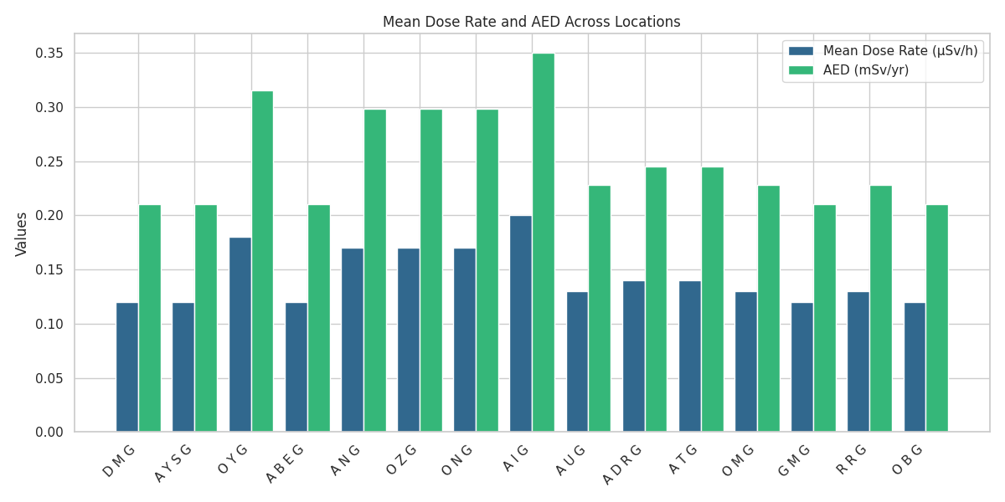
Figure 1: Mean Dose Rate and Annual Effective Dose across locations

The bar chart from figure 1, illustrates a comparison between Mean Dose Rate (µSv/h) and Annual Effective Dose (AED, mSv/yr) across fifteen automobile mechanical workshops in Zaria metropolis. Each site is represented by paired bars, enabling straightforward evaluation of radiation exposure levels. Elevated values were observed at AIG and OYG, indicating relatively higher environmental radiation, while DMG, AYSG, and ABEG showed uniform readings, suggesting consistent exposure conditions. Overall, the chart highlights spatial variations and consistencies in radiation levels across the study locations, providing a clear visual representation of potential radiological differences within the investigated workshop environments.
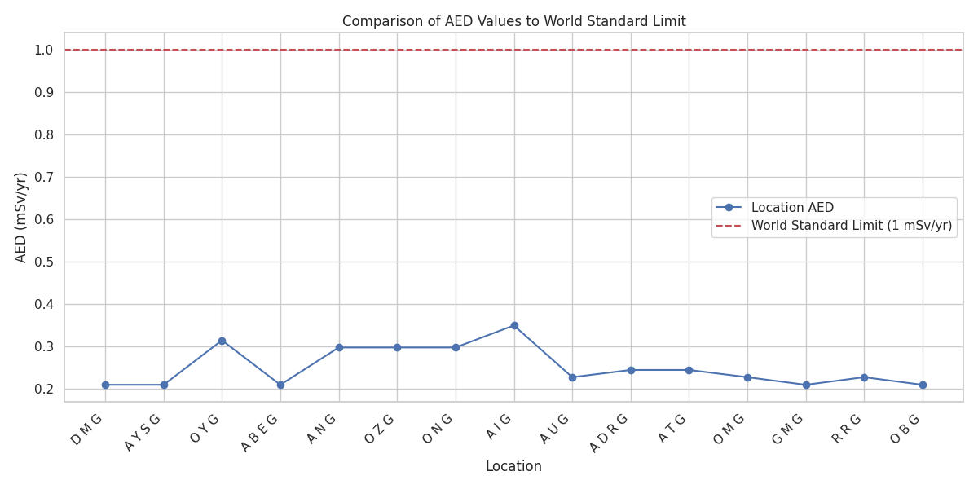
Figure 2: Comparison of AED values to World Standard Limit

Figure 2, depicts AED variations across fifteen locations, with all values well below the global safety threshold of 1 mSv/yr. AIG records the highest AED at 0.350 mSv/yr, while DMG, AYSG, and OBG show the lowest at 0.210 mSv/yr. The clear gap between the blue data line and the yellow dashed standard emphasizes the reassuringly low exposure levels across all surveyed areas, reflecting minimal radiological health risks within the studied workshops.
Table 3: Mean Annual Effective Dose (AED) with Other Related Studies
S/No | Location / Context | Region / Setting | Mean Annual Effective Dose (mSv/yr) | Reference
1 | Zaria (automobile workshops) | North Central Nigeria | 0.210 – 0.350 | Present Study
2 | Kabba (Kogi State) | North Central Nigeria | 0.75 – 1.09 | Bello et al., 2021
3 | Olusosun & Soluos III dumpsites (environmental) | Lagos, Southwest Nigeria | 0.065 (Soluos III), 0.092 (Olusosun) | Ademola et al., 2023
4 | Indoor hospital departments (pharmacy, radiology, radiotherapy) | Gombe, Northeast Nigeria | 0.379–0.437 (average ≈ 0.416) | Abdulkareem et al., 2024
5 | Natural ionizing radiation at tertiary institutions | Lapai & Zungeru, Niger State | ≈ 0.27 | Usman et al., 2021
6 | Ambient gamma + radon in drinking water (mining area) | Moro, North-Central Nigeria | Related study (not explicit AED) | Orosun et al., 2021
7 | Scrap sites, mechanic & wood workshops | Delta State, South-South Nigeria | 0.12 – 0.32 | Ukokeno et al.,
8 | Contaminated mechanic workshop soils | Southwest Nigeria | ≈ 0.21 – 0.33 (derived AED) | Olaoye, 2023
9 | Indoor vs. outdoor radiation in industrial buildings | Nnewi, Southeast Nigeria | 0.23 – 0.35 | Ugwuanyi et al.,
10 | Nationwide background radiation review | Nigeria (various states) | Range: 0.1 – 1.1 | Samaila et al., 2022
11 | Quarry site (background radiation & toxic elements) | Southeastern Nigeria | ≈ 0.29 | Ofomola, 2023

Table 3 presents a comparative analysis of mean annual effective doses (AED) across different Nigerian contexts. The present study in Zaria workshops (0.210–0.350 mSv/yr) shows values consistent with related investigations in mechanic and industrial environments, such as Delta State (0.12–0.32 mSv/yr) and contaminated soils in Southwest Nigeria (≈0.21–0.33 mSv/yr). Higher exposures were observed in Kabba (0.75–1.09 mSv/yr), likely due to geological formations or soil radionuclide enrichment, while lower levels were recorded at Lagos dumpsites (0.065–0.092 mSv/yr). Overall, reported AEDs fall below the ICRP recommended public exposure limit of 1 mSv/yr, indicating minimal health risks.

Conclusion
This study assessed the mean dose rate and annual effective dose (AED) of ionizing radiation in automobile mechanical workshops across Zaria, Nigeria. Results revealed dose rates between 0.12 and 0.20 µSv/h, translating into AEDs of 0.210–0.350 mSv/yr, all below the ICRP public exposure limit of 1.0 mSv/yr. Comparative analysis with related studies across Nigeria confirmed consistency with global background radiation levels. Variations observed among locations may be linked to environmental conditions, soil composition, and workshop practices. Overall, findings suggest no significant radiological health risks but emphasize the need for periodic monitoring to ensure sustained radiation safety.
Acknowledgements
The authors sincerely acknowledge the Department of Physics, Ahmadu Bello University, Zaria, Nigeria, for providing the technical support and research facilities that made this study possible.
Disclosure statement
No potential conflict of interest was reported by the author(s).

REFERENCES
Abdulkareem, I. H., Abubakar, I. S., Umar, M., & Tukur, M. (2024). Assessment of annual effective dose from background ionizing radiation exposure in selected hospital departments in Gombe, Nigeria. Radiation Physics and Chemistry, 217, 110186. https://doi.org/10.1016/j.radphyschem.2023.110186
Ademola, J. A., Oladapo, O. M., Ajiboye, R. I., Arogunjo, A. M., & Olowokere, T. A. (2023). Radiological assessment of municipal solid waste dumpsites in Lagos, Nigeria. Journal of Environmental Radioactivity, 264, 107219. https://doi.org/10.1016/j.jenvrad.2023.107219
Avwiri, G. O., Enyinna, P. I., & Agbalagba, E. O. (2010). Terrestrial radiation around oil and gas facilities in Ughelli, Nigeria. Journal of Applied Sciences and Environmental Management, 14(1), 31–35. https://doi.org/10.4314/jasem.v14i1.56564
Bello, I. A., Ige, O. O., Kure, N., & Momoh, A. H. (2021). Determination of radiation dose level at Kabba College of Agriculture, Division of Agricultural Colleges, Ahmadu Bello University, Zaria. FUDMA Journal of Sciences, 5(1), 524–528.
Bello, I. A., Umar, M. A., & Muhammad, A. (2021). Assessment of environmental gamma radiation dose rates in selected areas of Zaria, Nigeria. Journal of Applied Sciences and Environmental Management, 25(4), 647–652.
Ezemba, C. C., Agbo, P. U., & Anoka, O. C. (2025). Evaluation of background ionizing radiation in selected communities of Anambra South, Nigeria. Environmental Earth Sciences, 84(2), 177–185.
Ford, E. S. (2004). Radiation and human health: An overview. Health Physics, 86(2), 139–150. https://doi.org/10.1097/00004032-200402000-00001
Haider, S., & Mahmood, Q. (2015). Health hazards of ionizing radiation and their protection: A review. Journal of Radiation Research and Applied Sciences, 8(3), 498–505. https://doi.org/10.1016/j.jrras.2015.03.003
Howdershelt, J. (2000). Radiation safety in scrap metal recycling. Health Physics, 78(2), S161–S165.
International Commission on Radiological Protection (ICRP). (1991). 1990 recommendations of the International Commission on Radiological Protection (ICRP Publication 60). Pergamon Press.
Lenka, P., & Peter, H. (2010). Radiological safety issues in scrap metal management. Radiation Protection Dosimetry, 140(3), 262–267. https://doi.org/10.1093/rpd/ncq107
Minnesota Department of Health (MDH). (2008). Environmental radiation monitoring program annual report. Radiation Control Unit, Minnesota Department of Health.
National Population Commission (NPC). (2006). Population and housing census of the Federal Republic of Nigeria: Priority tables. National Population Commission.
Ofomola, M. O. (2023). Geological influence on background radiation levels in selected quarry sites of Southeastern Nigeria. Nigerian Journal of Physics, 35(2), 91–100.
Olarinoye, I. O., Sharifat, I. A., & Mustapha, A. O. (2010). Measurement of environmental background radiation levels at Kwara State, Nigeria. Science World Journal, 5(1), 15–19.
Orosun, M. M., Oladapo, O. M., Balogun, F. A., & Ademola, J. A. (2021). Assessment of ambient gamma dose and radon in groundwater of Moro, North-Central Nigeria. Environmental Earth Sciences, 80, 351. https://doi.org/10.1007/s12665-021-09688-7
Orosun, M. M., Umaru, I., & Yakubu, I. (2021). Outdoor and indoor gamma dose rate levels in parts of Kaduna State, Nigeria. Radiation Protection and Environment, 44(2), 77–85.
Olaoye, O. (2023). Distribution and assessment of radionuclides in soils around mechanic workshops in Southwestern Nigeria. Environmental Research Communications, 5(4), 045002.
Oyeyinka, O. A., Oladapo, O. M., & Awodugba, A. O. (2012). Natural radioactivity in some building materials in Nigeria and their radiological implications. Journal of Natural Sciences Research, 2(7), 1–6.
Rangacharyulu, C. (2013). Physics of nuclear radiation: Concepts, techniques, and applications. CRC Press.
Samaila, U., Nnadi, F. C., & Lawal, M. (2022). A review of environmental radiation studies in Nigeria: Gaps and prospects. African Journal of Environmental Science and Technology, 16(6), 201–213.
Tayyeb, Z. A., Khan, A. S., & Qureshi, A. A. (2012). Environmental gamma radiation measurements and dose estimation in selected locations of Jeddah, Saudi Arabia. Radiation Protection Dosimetry, 150(4), 542–546.
Tchokossa, P., Olomo, J. B., & Osibote, O. A. (2012). Radioactivity in the community water supply in three gold mining areas of Osun State, Nigeria. Journal of Environmental Radioactivity, 105, 30–36. https://doi.org/10.1016/j.jenvrad.2011.10.005
Turner, J. E. (2007). Atoms, radiation, and radiation protection (3rd ed.). Wiley-VCH.
Ugwuanyi, J. U., Eze, C. U., & Ononugbo, C. (2022). Comparative study of background radiation levels around selected industrial and non-industrial buildings in Enugu State, Nigeria. Journal of Radiation Research and Applied Sciences, 15(1), 1–10.
Ukokeno, M. O., Omonigho, J. M., & Edewor, T. I. (2024). Environmental radiation assessment of scrap sites, automobile and wood workshops in Delta State, Nigeria. Radiation Physics and Chemistry, 213, 111046.
United Nations Scientific Committee on the Effects of Atomic Radiation (UNSCEAR). (2000). Sources and effects of ionizing radiation: UNSCEAR 2000 report to the General Assembly, with scientific annexes. United Nations.
Usman, A., Mohammed, S., & Bello, I. A. (2021). Gamma radiation levels in the vicinity of industrial activities in Kaduna State, Nigeria. Journal of Environmental Radioactivity, 234, 106632.
Usman, Y. T., Jibrin, A. Y., Ishaq, Y., Bello, S., & Yahaya, M. A. (2022). Assessment of natural ionizing radiation in two tertiary institutions of Niger State. FUDMA Journal of Sciences, 5(4), 161–188. https://doi.org/10.33003/fjs-2021-0504-800

