Lung Cancer Classification in Large Biomedical Chest CT Images
using Deep Learning Models

Ayodele Oloyede¹, John Akintayo¹, Hanat Raji-Lawal¹, Kehinde Sotonwa¹, Tola Ajagbe¹, Omoyemi Orioke¹, Oluwole Olajide¹, Funmilayo Olopade^{2,3}, Benjamin Aribisala^{1,3}

¹Department of Computer Science, Lagos State University, Nigeria
²Department of Medicine, University of Chicago, Chicago, USA
³Center for Clinical Cancer Genetics and Global Health, University of Chicago; Chicago, USA

Abstract
Lung cancer continues to be one of the most common and lethal cancers globally, highlighting the necessity for precise and early diagnosis. This research assesses and compares the effectiveness of three deep learning models; Customized Convolutional Neural Network (CNN), ResNet-50, and VGG-16 for detecting lung cancer using extensive biomedical chest CT images. The models are evaluated based on three main metrics: precision, recall, and F1-score, which assess their reliability, sensitivity, and overall effectiveness. The customized CNN model achieves near-perfect accuracy, correctly classifying 99% of the cases. This indicates that the customized CNN is highly reliable for lung cancer detection. VGG-16 model correctly classified 96% of all cases, reflecting its strong overall performance. ResNet-50 model correctly classified 79% of the total cases. This reflects reasonable performance overall but highlights the model's difficulty with specific classes, especially Normal cases.
Customized CNN model stands out as the top-performing model, recording the highest precision of 99%. Its residual learning approach successfully addresses vanishing gradient challenges, enabling it to extract significant features from the complex patterns presented in chest CT scans, resulting in better accuracy and generalization. These results underscore Customized CNN's potential for use in clinical settings for lung cancer detection, providing both robustness and high diagnostic precision. The comparative analysis emphasizes the critical role of model architecture in managing large biomedical datasets and enhancing diagnostic results. Future efforts will concentrate on refining these models for real-time use and integrating additional clinical factors to improve diagnostic dependability.

Keywords:
lung cancer; machine learning; deep learning; positron emission tomography; computed tomography; convolutional neural network

1. Introduction
Lung cancer (LC) is a type of cancer that arises from lung cells, particularly those found in the epithelial lining of the bronchi, bronchioles, or alveoli [1]. It is widespread and linked to high mortality rates worldwide. In its initial stages, LC often shows no symptoms or presents only mild signs [2], [35]. Consequently, it is usually diagnosed when the disease has reached an advanced stage. This delay in recognizing the condition impacts the effectiveness of treatment and reduces the chances for long-term survival [3]. The two primary forms of LC are non-small cell lung cancer (NSCLC) and small cell lung cancer (SCLC). NSCLC is further divided into two subtypes: lung squamous cell carcinoma (LUSC) and lung adenocarcinoma (LUAD) [4]. The detailed classification of LC, which includes LUSC, LUAD, and SCLC, is crucial for determining the prognosis of the disease in comparison to both benign and malignant classifications. Accurately distinguishing LC at the initial diagnostic stage greatly enhances treatment effectiveness and subsequently boosts the survival rates of patients [35], [5]. CT scans are widely used as non-invasive imaging techniques in clinical settings, providing essential support for the specific diagnosis of LC [6].

Timely identification and management of LC through efficient screening methods are critical for improving patient outcomes. According to the National Lung Screening Trial results, screening with low-dose helical CT is more successful in lowering mortality rates among high-risk groups [7]. However, the LC screening process can produce false positive (FP) results, which can lead to increased healthcare costs due to unnecessary medical procedures and provoke psychological stress in individuals [34], [8]. The use of computer-aided diagnosis offers significant benefits for detecting LC, including a broader capability for early cancer screening and a reduced incidence of FP results during the diagnostic process [9].

In the field of lung cancer (LC) detection, significant advancements have been made through innovative techniques and technologies aimed at improving early diagnosis and treatment effectiveness. Liquid biopsies analyse blood samples to identify cancerous conditions. These diagnostic procedures can reveal genetic alterations and variations linked to LC, providing a non-invasive means for diagnosing the disease and tracking treatment success. Low-dose computed tomography (LDCT) screening has become a commonly used approach for the early detection of LC. LDCT scans utilize lower radiation doses compared to traditional CT scans while producing high-quality images of the lung area. New bronchoscopic techniques, such as electromagnetic navigation bronchoscopy and robotic-assisted bronchoscopy, enable the execution of minimally invasive biopsies for lung lesions. These tools enhance the ability to quickly and accurately diagnose medical issues. The integration of genomics, proteomics, and metabolomics has led to the creation of various strategies for identifying LC. These approaches utilize multiple molecular markers to improve diagnostic accuracy and identify potential targets for treatment.

DL-driven lung cancer screening approaches can lead to a decrease in mortality by identifying the illness at an early stage. They can help diminish false negatives by recognizing subtle or initial signs of lung cancer that might be overlooked by human observers. Imaging techniques such as CT scans, MRI, and PET can be combined with deep learning algorithms to enhance understanding of the disease and support diagnosis and treatment planning. Cancer staging is closely linked to the degree of disease spread [35]. Utilizing a mix of imaging techniques and biopsies from suspicious tissues helps to classify cancer types. Cancer staging guides healthcare providers in choosing chemotherapy, immunotherapy, radiation, and surgical options. Specifically, a higher stage of cancer correlates with an increased mortality rate. The efficacy of medical treatments is dependent on the cancer stage. Providing more precise and reliable diagnoses can minimize misdiagnosis and unnecessary treatments. Lung cancer screening generates large amounts of medical imaging data. Deep learning models are adept at analyzing CT images [36]. chest X-rays, and other imaging techniques due to their capacity to process extensive datasets. By leveraging deep learning models, clinicians can gain valuable insights into a patient's condition by integrating information from various imaging methods and other clinical data sources [34].

Medical image datasets are often limited due to privacy issues and the high costs associated with data collection. Pre-trained models can utilize their knowledge from broader image datasets on medical images, allowing for model training with limited medical data, [36]. These models are capable of extracting nuanced information from images, identifying intricate details and important patterns. The feature extraction process assists medical image classification models in recognizing critical patterns, anomalies, and signs of disease. Training convolutional neural network models from the ground up can entail considerable computing expenses and require a significant amount of time, [36]. The strategy of deep transfer learning can considerably shorten the training time and reduce the duration needed to fine-tune the model for medical image classification.

The diagnosis and classification of lung carcinoma (LC) heavily depend on CT imaging. CT images are integrated into CT-based models for LC detection to analyze the location, size, and metabolic activity of lung lesions. CT scans are utilized for monitoring the effectiveness of cancer treatments. By observing changes in metabolic activity and tumor growth over time, the evaluation of treatment success can be enhanced. Using CT imaging to distinguish between LC types and characteristics enables personalized treatment approaches. Bhandary et al. [20] developed a deep learning framework to identify LC through CT images. Kanavati et al. [21] proposed a model based on weakly-supervised learning to detect lung carcinoma. Hallitschke et al. [22] created a multimodal technique for the segmentation of LC lesions to annotate images. They employed the geodesic distance transformation method and executed an ellipsoid-based user simulation approach. Ardila et al. [23] launched an end-to-end model for LC screening utilizing low-dose CT (LDCT) images. Marentakis et al. [24] introduced a method for the histological classification of LC.

2. Materials and Methods
The quality of medical imaging can influence the effectiveness of feature segmentation methods. Noise, artifacts, or images with low resolution can reduce the effectiveness of feature extraction. Feature segmentation methods usually rely on predefined feature sets, which might not cover all relevant information necessary for identifying lung cancer. Certain feature segmentation algorithms may require significant computational power when processing large datasets of medical images, potentially limiting their use in environments with restricted resources. Variations in patient positioning and imaging parameters can adversely affect the precision of feature segmentation techniques.

2.1. Image Acquisition
We employed the CT (IQ-OTH/NCCD) lung cancer dataset to enhance the generalization of the proposed lung cancer detection model. This dataset comprises CT scans of patients at various stages of lung cancer, in addition to scans from healthy individuals. The IQ-OTH/NCCD slides were annotated by oncologists and radiologists from these two institutions. A total of 1190 images depicting CT scan slices from 110 cases are included in the dataset. These images were collected retrospectively from the Iraq-Oncology Teaching Hospital/National Center for Cancer Diseases over a three-month span in the fall of 2019. It encompasses CT scans from patients at different stages of lung cancer, as well as healthy subjects. The IQ-OTH/NCCD slides were labeled by oncologists and radiologists from these two facilities.
2.2. Image Preprocessing
The preprocessing phase is essential for improving the quality of input data, minimizing computational demands, and increasing the precision of deep learning models when preparing CT images to be used as input for customized CNN, VGG-16, and ResNet-50 models.

2.2.1 Resizing and Normalization
CT images differ in dimensions and intensity, necessitating standardization for reliable model performance. Each CT image is adjusted to a uniform size. The CT images underwent pre-processing by being resized to a standard dimension of 512x512 pixels to enhance classification accuracy, utilizing the Trilinear Interpolation method as shown in equation (1), and the Hounsfield Units (HU) were normalized through Min-Max Scaling to rescale the clipped pixel values to the range [0,1], which helps the model learn effectively and make predictions. For an input image of size H×W and a target size of Ht×Wt, target coordinates (x,y,z) must be mapped to source coordinates (xs,ys,zs).

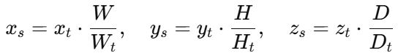 (1)
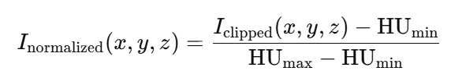 (2)

2.2.2 Noise and Artifact Reduction
Noise and artifacts are mitigated using Gaussian filter.
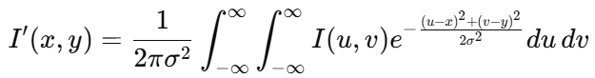 (3)

2.3. Image Augmentation
Augmentation diversifies the dataset to prevent overfitting. Using rotation technique. The geometric transformations are used to generate variations in the image sizes. The images are rotated to 30, 60, 90, and 120 degrees to simulate deviations in the orientation of the patients.

2.4. Feature Extraction
Feature extraction can be achieved through transfer learning utilizing pre-trained models or by training from scratch with domain-specific data. In this study, three models were employed: a customized CNN, ResNet-50, and VGG-16. CT scan images were processed through the convolutional and pooling layers of each CNN model, and the features were derived from the output of the last convolutional or pooling layer. For ResNet-50, features were extracted from the Global Average Pooling layer, while VGG-16 utilized the flattened output from the FC layers (FC6, FC7) or the final pooling layer. Figures 2.1, 2.2, and 2.3 illustrate the block diagrams of basic CNN, ResNet-50, and VGG-16 architectures, respectively, which are used to classify CT scan images.

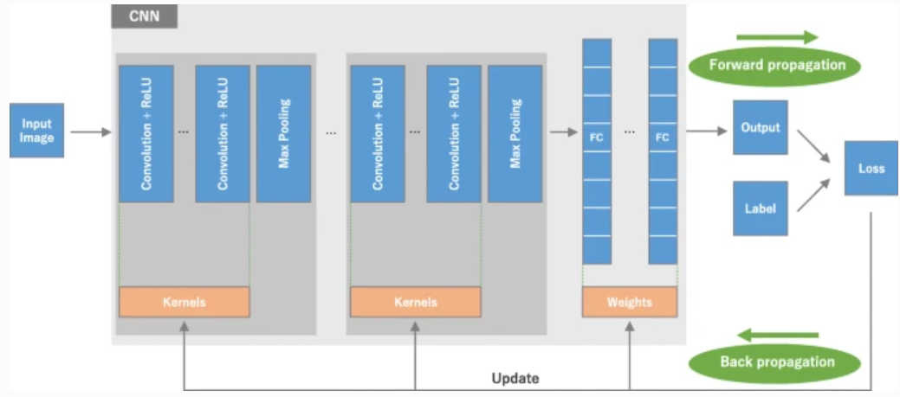
Fig 2.1: Block diagram of basic CNN architecture

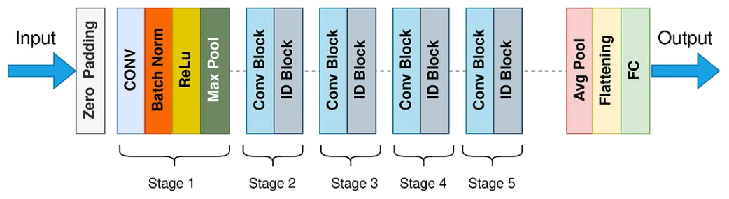
Fig. 2.2: Block diagram of ResNet-50 architecture

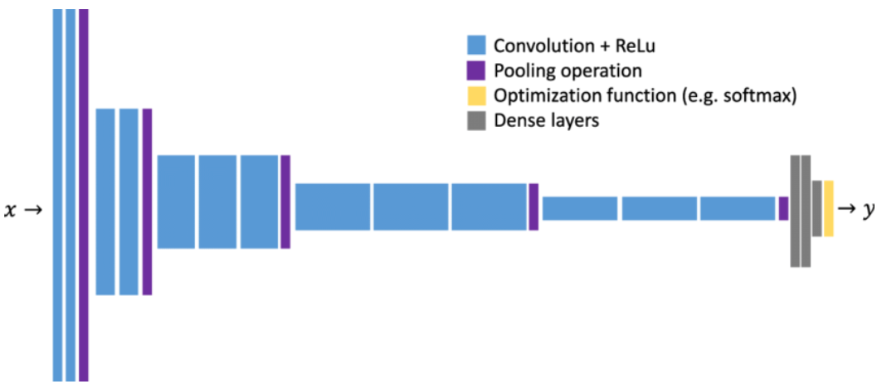
Fig. 2.3: Block diagram of VGG-16 architecture

2.5. Dimensionality Reduction
Principal Component Analysis (PCA) is a statistical technique employed for reducing the dimensionality of CT images by converting high-dimensional data into a lower-dimensional format while retaining the most crucial information. In the comparison of CNN, ResNet-50, and VGG-16 for lung cancer detection, PCA was utilized to extract feature vectors from these models to lessen computational demands, reduce the risk of overfitting, and improve interpretability without significantly affecting performance [37]. The features from the CT scans were standardized to achieve a mean of zero and a unit variance, considering that PCA is sensitive to the scale.

2.6. LC Classification Model
This study utilized customized CNN, ResNet-50, and VGG-16 to categorize CT scan images obtained from the IQ-OTH/NCCD lung cancer dataset into three distinct groups: Normal cases, Benign cases, and Malignant cases. The lung cancer dataset was accessed using image_dataset_from_directory from TensorFlow. A total of 1,097 files were identified across the three classes, with 878 files allocated for training and 219 files designated for validation. The dataset was divided with 80% for training and 20% for validation. The models were constructed using TensorFlow and the Keras functional API, and they were trained and assessed on a set of lung cancer images. The models underwent training for 5 epochs utilizing the training dataset, and their performance was validated against the validation dataset after each epoch. The training procedure was monitored using accuracy and loss metrics. Alongside accuracy and loss metrics, the models' performance was further evaluated with a Confusion Matrix, a Classification Report, and a ROC Curve with AUC to determine the classifier's ability to differentiate between classes. Figure 2.4 displays CT lung images representing Normal cases, Benign cases, and Malignant cases as utilized in this study. The validation accuracy and validation loss were graphed to illustrate the evolution of the models' performance over time during the training phase, as depicted in Figure 2.5, 2.6 and 2.7 for Normal cases, Benign cases, and Malignant cases respectively.
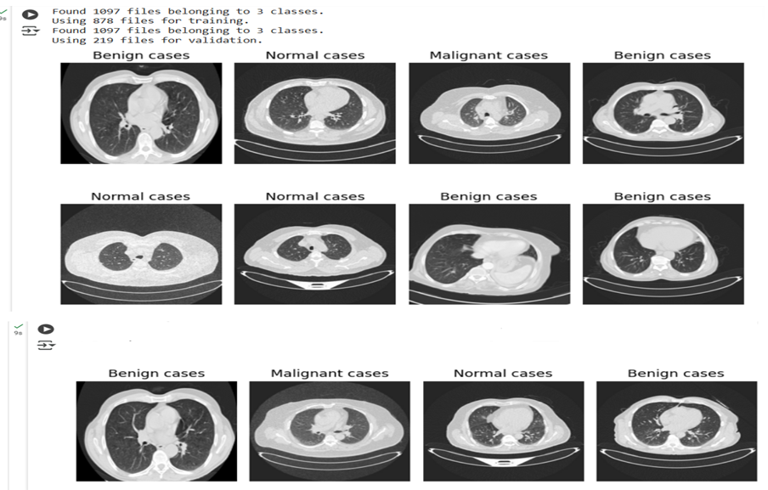
Fig. 2.4: CT lung images of Normal cases, Benign cases, and Malignant cases.

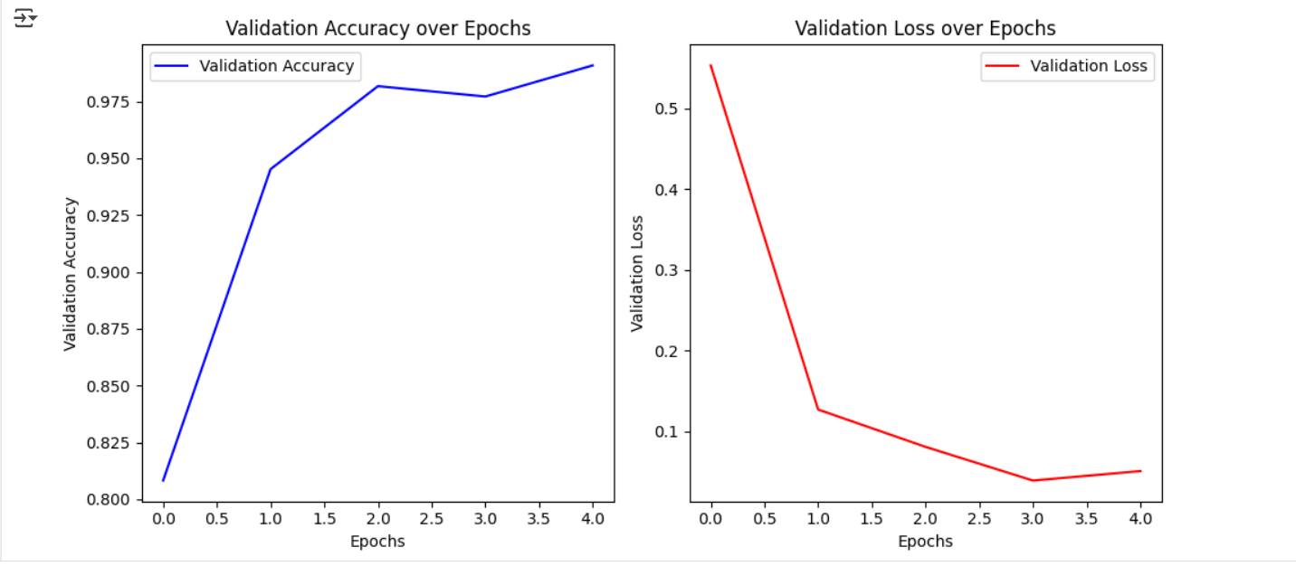
Fig. 2.5: Graph of validation accuracy and validation loss customized CNN model

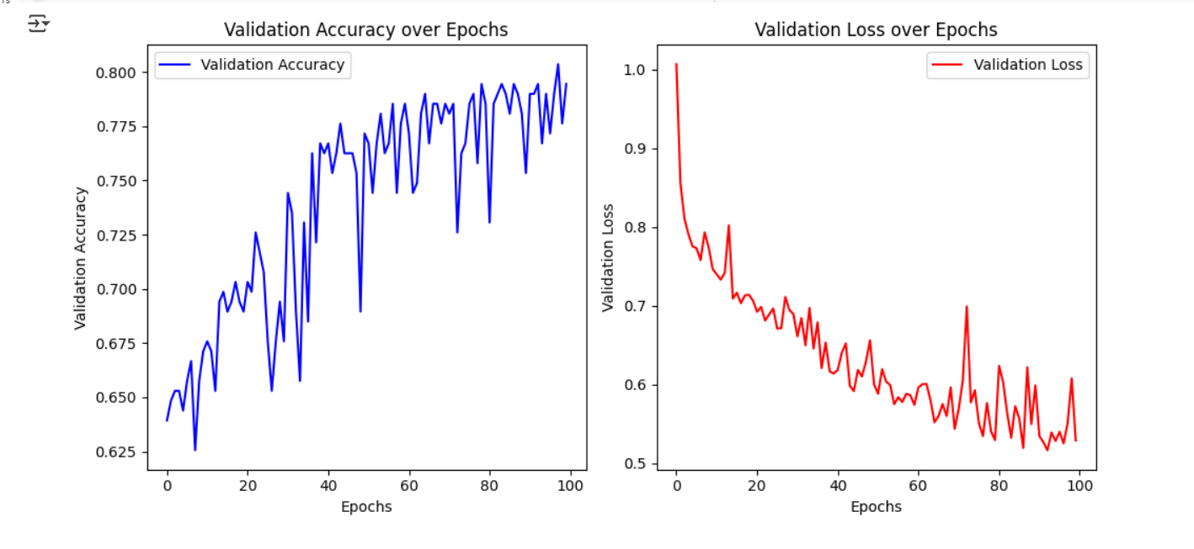
Fig. 2.6: Graph of validation accuracy and validation loss ResNet-50 model

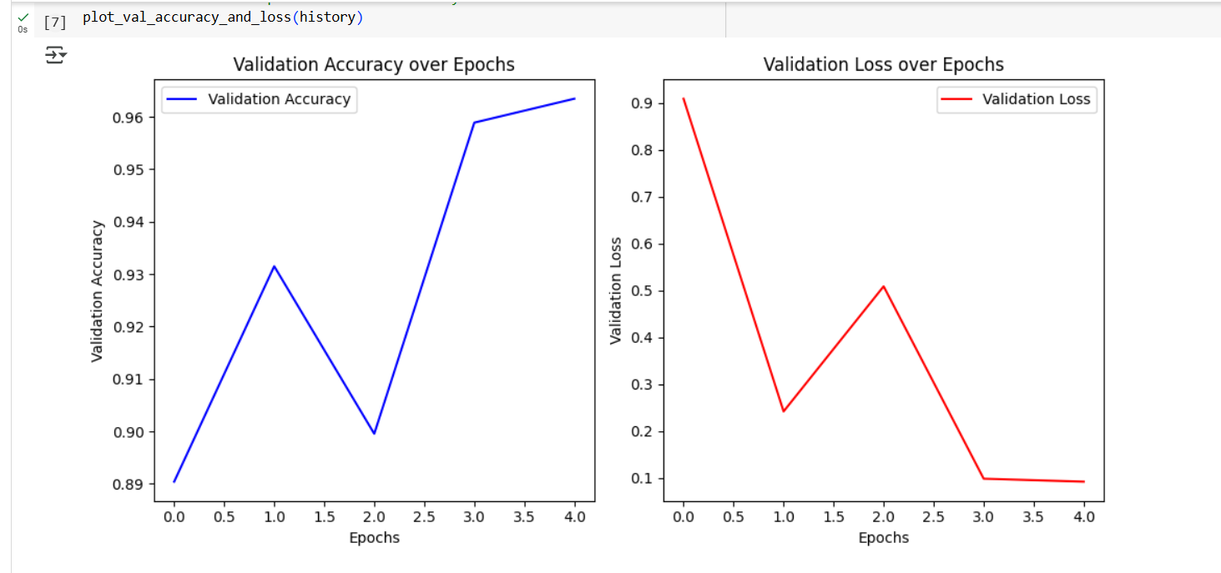
Fig. 2.7: Graph of validation accuracy and validation loss customized VGG-16 model

2.7 Evaluation Metrics
In the realm of land cover, (LC) detection and classification, the terms true positives (TP), true negatives (TN), false positives (FP), and false negatives (FN) have specific interpretations. A true positive refers to a specific LC type that has been correctly identified, while a true negative signifies an image that accurately corresponds to a different LC type. A false positive indicates an LC type that has been misidentified, and a false negative pertains to an image that actually belongs to a different LC type but was wrongly identified. We adhered to standard evaluation metrics to assess the proposed model in this research. The accuracy metric evaluates the quality of the model's predictions, measuring the ratio of correctly predicted instances—including both TP and TN—against the total number of instances in the dataset. Precision represents the fraction of instances in which the model made a positive prediction. Recall measures the proportion of true positives among all actual positive cases. The F1-score is the harmonic mean of precision and recall. A greater F1-score indicates that the model reliably demonstrates both high levels of recall and precision. Additionally, the area under the receiver operating characteristic curve (AU-ROC), the precision-recall curve (AU-PRC), and the loss function are also calculated for the LC detection models. Equations (4)–(7) provide the mathematical formulations for determining accuracy, precision, recall, and the F1 score.

$Accuracy=\frac{TP+TN}{TP+TN+FP+FN}$ (4)

$Precision=\frac{TP}{TP+FP}$ (5)
$Recall=\frac{TP}{TP+FN}$ (6)
$F1-score=\frac{2* precision* recall}{Tprecision x+recal}$ (7)

3. Results
The experiment was carried out using Python 3.8.3 with the Keras library. The designed model was implemented on Windows 10, featuring an Intel i7 processor and 16 GB of RAM. We obtained the weights for the customized CNN, VGG-16, and ResNet-50 models from a repository. The models demonstrated outstanding performance, achieving an accuracy of 99% for the customized CNN model, 96% for the VGG-16 model, and 79% for the ResNet-50 model on the validation set. The classification report presented the following key metrics as shown in tables 3.1 to 3.5:

Table 1: Classification Report for customized CNN model
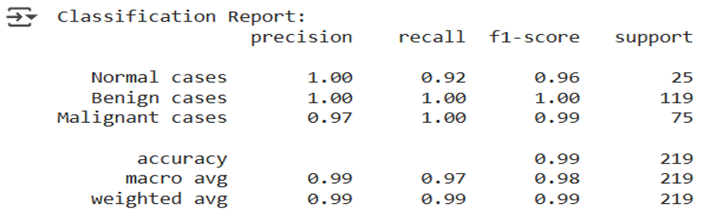

Table 2: Classification Report for VGG-16 model
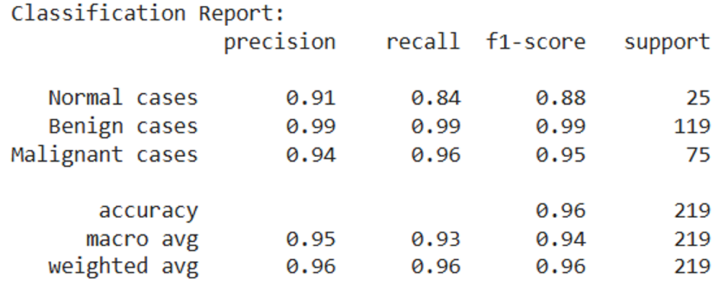

Table 3: Classification Report for ResNet-50 model

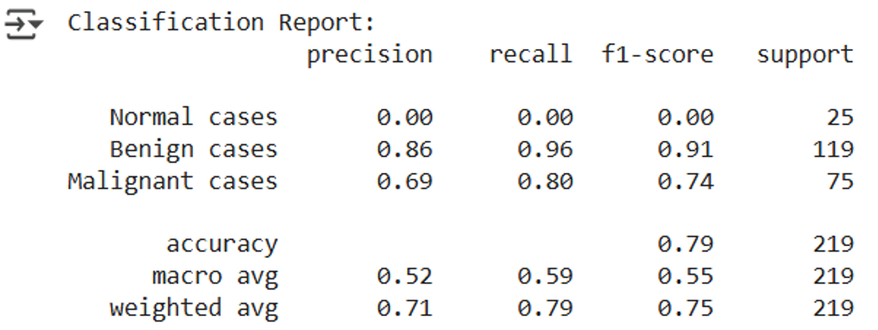

Confusion Matrix which indicates that the models are reliable for classifying lung cancer images into the three categories are shown in figures 2.8 – 1.10 for customized CNN model, VGG-16 model and ResNet-50 model.

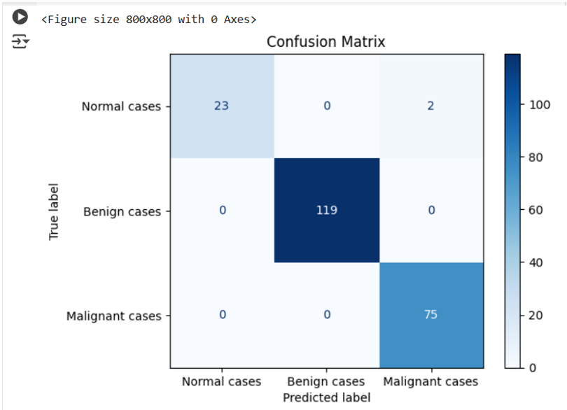
Fig. 2.8: Confusion Matrix for customized CNN model

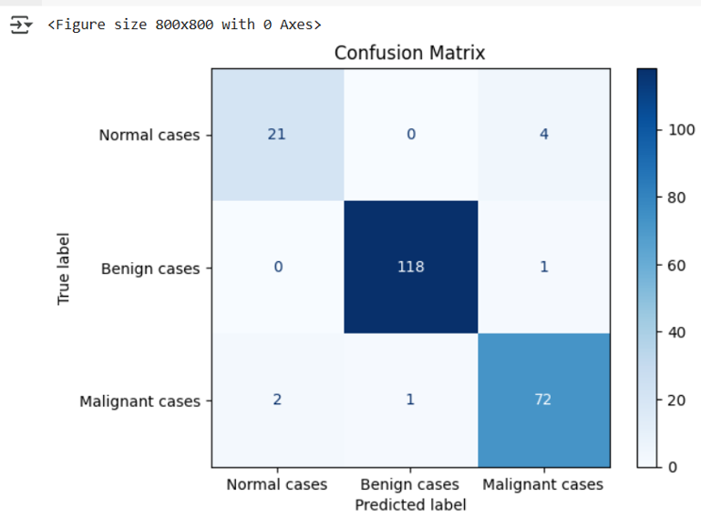
Fig. 2.9: Confusion Matrix for VGG-16 model

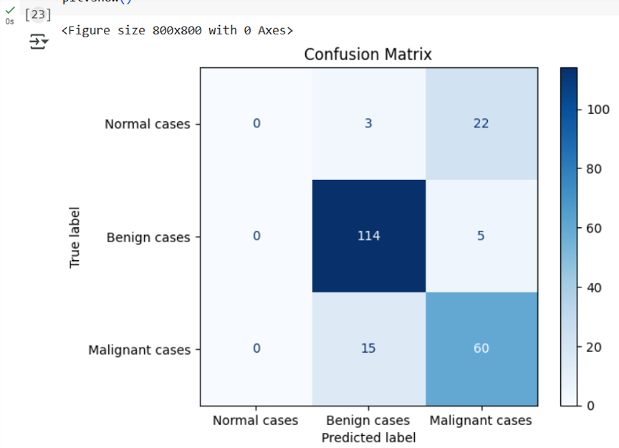
Fig. 2.10: Confusion Matrix for customized ResNet-50 model

The ROC curve, or Receiver Operating Characteristic Curve, visualizes the relationship between the True Positive Rate (TPR) and the False Positive Rate (FPR), offering a visual representation of how well the model differentiates between classes. The area under the ROC curve (AUC) serves as a comprehensive measure of the model's effectiveness. An AUC value approaching 1 signifies a robust model, whereas values nearing 0.5 indicate chance performance. In our analysis, the three models, the customized CNN model, VGG-16 model, and ResNet-50 model—exhibited AUC values close to 1, reflecting their exceptional ability to discriminate, as shown in figures 2.11 to 2.13.

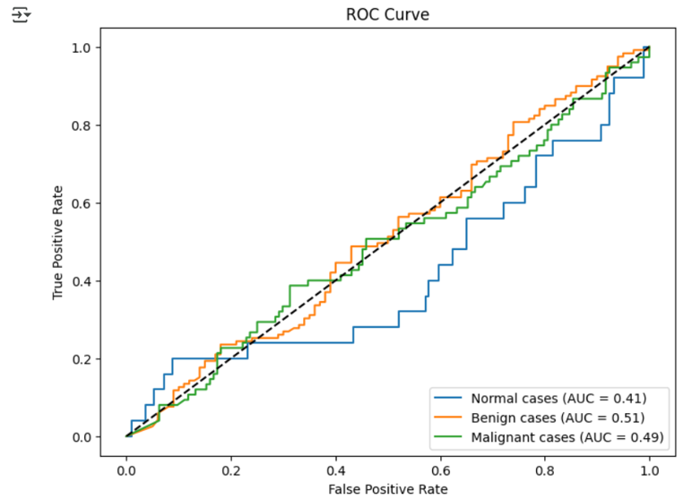
Fig. 211: The ROC curve for customized CNN model

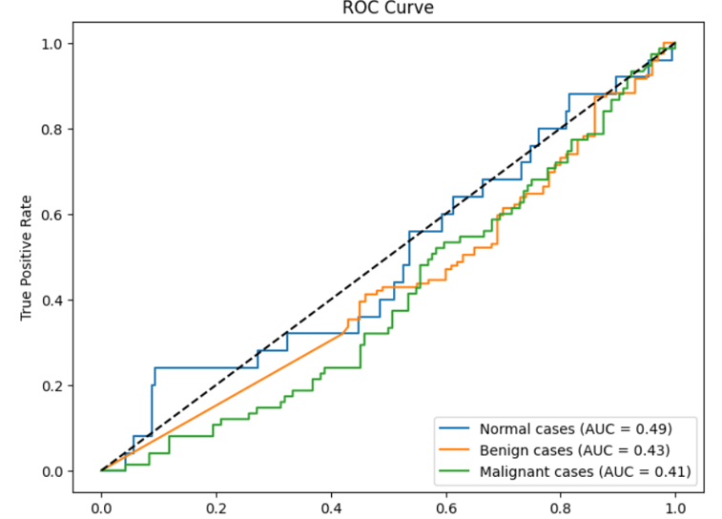
Fig. 212: The ROC curve for VGG-16 model

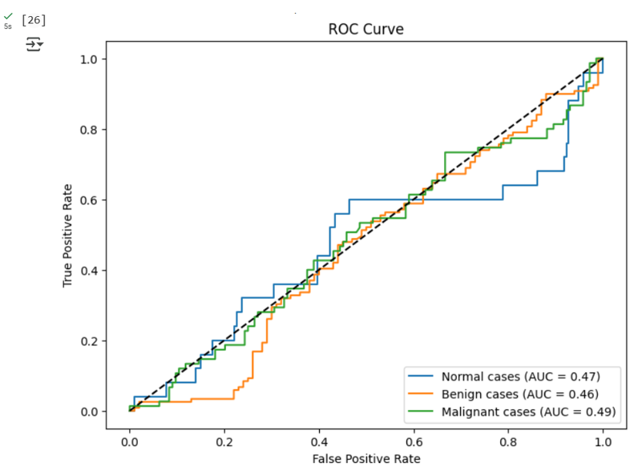
Fig. 213: The ROC curve for customized ResNet-50 model

4. Discussions
The effectiveness of the VGG-16 model, ResNet-50 model, and a tailored CNN model for lung cancer identification is assessed using the specified metrics. The outcomes are categorized by image types (Normal, Benign, and Malignant), along with overall metrics (Accuracy, Precision, F1-scores and Recall). The VGG-16 model successfully classified 96% of all instances, indicating its strong overall performance. The ResNet-50 model achieved an accuracy of 79% for the total cases, while this reflects acceptable performance overall, it reveals the model’s challenges, particularly with Normal cases. The customized CNN model reached nearly flawless accuracy, accurately classifying 99% of the instances. This suggests that the custom CNN is extremely dependable for lung cancer detection, as its perfect precision for Normal and Benign cases reduces false positives, and its high recall for all classes leads to minimal false negatives, crucial for clinical diagnostics. The F1-scores for all classes in the customized CNN model showcase a harmonious approach, effectively addressing class imbalances. The model performs exceptionally well in identifying Malignant cases, boasting high precision and perfect recall, making it very reliable for detecting potentially life-threatening situations.

5. Conclusion
The VGG-16 model shows impressive accuracy and consistent performance in detecting lung cancer from chest CT images, excelling particularly in distinguishing between Benign and Malignant cases; however, enhancements are required for managing Normal cases to decrease the occurrence of false negatives. The model's high precision, recall, and F1-scores highlight its promise for clinical application, especially in environments that demand precise differentiation between Benign and Malignant conditions. The ResNet-50 model exhibits solid performance in identifying Benign cases but struggles to recognize Normal cases, which significantly hampers its overall clinical reliability. Its moderate effectiveness in detecting Malignant cases indicates opportunities for enhancement through balanced training approaches and design improvements. Tackling class imbalance and placing emphasis on less represented cases are vital actions to render ResNet-50 a feasible option for lung cancer detection in chest CT images. The tailored CNN model achieves exceptional results in lung cancer detection, nearing perfect metrics across all categories. It excels in identifying both Benign and Malignant cases, rendering it highly appropriate for clinical application. Enhancing recall for Normal cases and reducing false positives in Malignant cases would further strengthen its credibility. In summary, the model offers a solid and effective solution for lung cancer identification in extensive biomedical chest CT datasets.

References

- Gu, Y.; Chi, J.; Liu, J.; Yang, L.; Zhang, B.; Yu, D.; Zhao, Y.; Lu, X. A survey of computer-aided diagnosis of lung nodules from CT scans using deep learning. Comput. Biol. Med. 2021, 137, 104806.
- Sharif, M.I.; Li, J.P.; Naz, J.; Rashid, I. A comprehensive review on multi-organs tumor detection based on machine learning. Pattern Recognit. Lett. 2020, 131, 30–37
- Adhikari, T.M.; Liska, H.; Sun, Z.; Wu, Y. A Review of Deep Learning Techniques Applied in Lung Cancer Diagnosis. In Signal and Information Processing, Networking and Computers: Proceedings of the 6th International Conference on Signal and Information Processing, Networking and Computers (ICSINC), Guiyang, China, 13–16 August 2019; Springer: Singapore, 2020; pp. 800–807.
- Saba, T. Recent advancement in cancer detection using machine learning: Systematic survey of decades, comparisons and challenges. J. Infect. Public Health 2020, 13, 1274–1289.
- Ozdemir, O.; Russell, R.L.; Berlin, A.A. A 3D probabilistic deep learning system for detection and diagnosis of lung cancer using low-dose CT scans. IEEE Trans. Med. Imaging 2019, 39, 1419–1429.
- Yu, L.; Tao, G.; Zhu, L.; Wang, G.; Li, Z.; Ye, J.; Chen, Q. Prediction of pathologic stage in non-small cell lung cancer using machine learning algorithm based on CT image feature analysis. BMC Cancer 2019, 19, 464.
- Asuntha, A.; Srinivasan, A. Deep learning for lung Cancer detection and classification. Multimed. Tools Appl. 2020, 79, 7731–7762.

- Shakeel, P.M.; Burhanuddin, M.A.; Desa, M.I. Lung cancer detection from CT image using improved profuse clustering and deep learning instantaneously trained neural networks. Measurement 2019, 145, 702–712.
- Xie, Y.; Meng, W.Y.; Li, R.Z.; Wang, Y.W.; Qian, X.; Chan, C.; Yu, Z.F.; Fan, X.X.; Pan, H.D.; Xie, C.; et al. Early lung cancer diagnostic biomarker discovery by machine learning methods. Transl. Oncol. 2021, 14, 100907.
- Sori, W.J.; Feng, J.; Godana, A.W.; Liu, S.; Gelmecha, D.J. DFD-Net: Lung cancer detection from denoised CT scan image using deep learning. Front. Comput. Sci. 2021, 15, 152701.
- Ak, M.F. A comparative analysis of breast cancer detection and diagnosis using data visualization and machine learning applications. Healthcare 2020, 8, 111.
- Pradhan, K.; Chawla, P. Medical Internet of things using machine learning algorithms for lung cancer detection. J. Manag. Anal. 2020, 7, 591–623.
- Heuvelmans, M.A.; van Ooijen, P.M.; Ather, S.; Silva, C.F.; Han, D.; Heussel, C.P.; Hickes, W.; Kauczor, H.U.; Novotny, P.; Peschl, H.; et al. Lung cancer prediction by Deep Learning to identify benign lung nodules. Lung Cancer 2021, 154, 1–4.
- Singh, G.A.P.; Gupta, P.K. Performance analysis of various machine learning-based approaches for detection and classification of lung cancer in humans. Neural Comput. Appl. 2019, 31, 6863–6877.
- Sajja, T.; Devarapalli, R.; Kalluri, H. Lung Cancer Detection Based on CT Scan Images by Using Deep Transfer Learning. Trait. Du Signal 2019, 36, 339–344.
- Coccia, M. Deep learning technology for improving cancer care in society: New directions in cancer imaging driven by artificial intelligence. Technol. Soc. 2020, 60, 101198
- Bhatia, S.; Sinha, Y.; Goel, L. Lung cancer detection: A deep learning approach. In Soft Computing for Problem Solving: SocProS 2017; Springer: Singapore, 2019; Volume 2, pp. 699–705
- Nasrullah, N.; Sang, J.; Alam, M.S.; Mateen, M.; Cai, B.; Hu, H. Automated lung nodule detection and classification using deep learning combined with multiple strategies. Sensors 2019, 19, 3722.
- Chaunzwa, T.L.; Hosny, A.; Xu, Y.; Shafer, A.; Diao, N.; Lanuti, M.; Christiani, D.C.; Mak, R.H.; Aerts, H.J. Deep learning classification of lung cancer histology using CT images. Sci. Rep. 2021, 11, 5471.
- Bhandary, A.; Prabhu, G.A.; Rajinikanth, V.; Thanaraj, K.P.; Satapathy, S.C.; Robbins, D.E.; Shasky, C.; Zhang, Y.D.; Tavares, J.M.R.; Raja, N.S.M. Deep-learning framework to detect lung abnormality—A study with chest X-Ray and lung CT scan images. Pattern Recognit. Lett. 2020, 129, 271–278.
- Kanavati, F.; Toyokawa, G.; Momosaki, S.; Rambeau, M.; Kozuma, Y.; Shoji, F.; Yamazaki, K.; Takeo, S.; Iizuka, O.; Tsuneki, M. Weakly-supervised learning for lung carcinoma classification using deep learning. Sci. Rep. 2020, 10, 9297.
- Hallitschke, V.J.; Schlumberger, T.; Kataliakos, P.; Marinov, Z.; Kim, M.; Heiliger, L.; Seibold, C.; Kleesiek, J.; Stiefelhagen, R. Multimodal Interactive Lung Lesion Segmentation: A Framework for Annotating PET/CT Images based on Physiological and Anatomical Cues. arXiv 2023, arXiv:2301.09914.
- Ardila, D.; Kiraly, A.P.; Bharadwaj, S.; Choi, B.; Reicher, J.J.; Peng, L.; Tse, D.; Etemadi, M.; Ye, W.; Corrado, G.; et al. End-to-end lung cancer screening with three-dimensional deep learning on low-dose chest computed tomography. Nat. Med. 2019, 25, 954–961.
- Marentakis, P.; Karaiskos, P.; Kouloulias, V.; Kelekis, N.; Argentos, S.; Oikonomopoulos, N.; Loukas, C. Lung cancer histology classification from CT images based on radiomics and deep learning models. Med. Biol. Eng. Comput. 2021, 59, 215–226. [
- Chabon, J.J.; Hamilton, E.G.; Kurtz, D.M.; Esfahani, M.S.; Moding, E.J.; Stehr, H.; Schroers-Martin, J.; Nabet, B.Y.; Chen, B.; Chaudhuri, A.A.; et al. Integrating genomic features for non-invasive early lung cancer detection. Nature 2020, 580, 245–251.
- Zhang, R.; Cheng, C.; Zhao, X.; Li, X. Multiscale mask R-CNN–based lung tumor detection using PET imaging. Mol. Imaging 2019, 18, 1536012119863531.
- Kriegsmann, M.; Haag, C.; Weis, C.A.; Steinbuss, G.; Warth, A.; Zgorzelski, C.; Muley, T.; Winter, H.; Eichhorn, M.E.; Eichhorn, F.; et al. Deep learning for the classification of small-cell and non-small-cell lung cancer. Cancers 2020, 12, 1604.
- Polat, H.; Danaei Mehr, H. Classification of pulmonary CT images by using hybrid 3D-deep convolutional neural network architecture. Appl. Sci. 2019, 9, 940.
- Patel, D.; Shah, Y.; Thakkar, N.; Shah, K.; Shah, M. Implementation of artificial intelligence techniques for cancer detection. Augment. Hum. Res. 2020, 5, 6.
- Baranwal, N.; Doravari, P.; Kachhoria, R. Classification of histopathology images of lung cancer using convolutional neural network (CNN). In Disruptive Developments in Biomedical Applications; CRC Press: Boca Raton, FL, USA, 2022; pp. 75–89.
- Levy-Jurgenson, A.; Tekpli, X.; Kristensen, V.N.; Yakhini, Z. Spatial transcriptomics inferred from pathology whole-slide images links tumor heterogeneity to survival in breast and lung cancer. Sci. Rep. 2020, 10, 18802.
- Mishra, S.; Thakkar, H.K.; Mallick, P.K.; Tiwari, P.; Alamri, A. A sustainable IoHT based computationally intelligent healthcare monitoring system for lung cancer risk detection. Sustain. Cities Soc. 2021, 72, 103079.
- Luna, J.M.; Chao, H.H.; Diffenderfer, E.S.; Valdes, G.; Chinniah, C.; Ma, G.; Cengel, K.A.; Solberg, T.D.; Berman, A.T.; Simone, C.B., II. Predicting radiation pneumonitis in locally advanced stage II–III non-small cell lung cancer using machine learning. Radiother. Oncol. 2019, 133, 106–112.
- Fagbola Temitayo Matthew,, Egbetola Funmilola Ikeolu,, Emuoyibofarhe Justice,, Olaniyan Olatayo Moses,, Oloyede Ayodele,, Akinpelu James: e-HAMS=A UNIFIED MODEL--BASED INTEGRATED HEALTHCARE SERVICES MANAGEMENT SYSTEM FOR LOW--AND--MIDDLE INCOME ECONOMIES. http://anale-informatica.tibiscus.ro/download/lucrari/16-1-04-Fagbola.pdf
- Babatunde Ronke. S, Adepoju Morufat. T, Oloyede Ayodele. O: Towards Detection of Congenital Birth Defect in Newborn using Autoencoder Neural Network. Adeleke journal of Engineering and Technology. AUJET Vol. 2 No 6, 227-236 (2023) https://aujet.adelekeuniversity.edu.ng/index.php/aujet/issue/view/11
- Temitayo Matthew Fagbola, Ibrahim Adepoju Adeyanju, Olatayo Olaniyan, Adebimpe Esan, Bolaji Omodunbi, Ayodele Oloyede, Funmilola Egbetola: Development of Mobile-Interfaced Machine Learning-Based Predictive Models for Improving Students Performance in Programming Courses. (IJACSA) International Journal of Advanced Computer Science and Applications, Vol. 9, No. 5, 2018https://thesai.org/Publications/ViewIssue?volume=9&issue=5&code=IJACSA
- Oloyede Ayodele, Fagbola Temitayo, Olabiyisi Stephen, Omidiora Elijah and Oladosu John (2016): Development of a Modified Local Binary Pattern-Gabor Wavelet Transform Aging Invariant Face Recognition System. ACM International Computing Research & Innovations, University of Ibadan, Nigeria, September 2016. pp. 108-114. (https://acmng.acm.org/cori2016-proceedings/)

