Title: Application of System Dynamics and Systems Thinking to Conceptual Frameworks for Impact Assessment of Agricultural Programs in Nigeria
Authors: R.C. Wakawa, Ajuwon Oluwadamilola, Mommoh E. B.
Affiliation: National Centre for Technology Management (NACETEM), North Central, Abuja, Office.
Corresponding Emails: rahichriswakawa@gmail.com, damilolaajuwon99@gmail.com and momohenyojoblessing@gmail.com
Orcid ID: R.C. Wakawa; 0000000306794318

Abstract

This paper explores the integration of Systems Thinking and System Dynamics modelling into conceptual frameworks for impact assessment of agricultural programs, addressing the limitations of traditional linear planning models in navigating the complex, interrelated challenges faced by modern agricultural systems. Utilising tools like Comodel and Loopy to develop causal loop diagrams, the study revealed how these models and frameworks impact agricultural programs by providing a holistic lens for understanding interconnectedness and a rigorous, simulation-based approach for testing dynamic hypotheses. The findings demonstrate that this integrated approach enables a crucial shift from reactive to proactive planning, enhancing ability to manage uncertainty, complexity, and illustrating how strategic interventions can trigger cascades of positive effects on technology adoption, food security, and household well-being. Consequently, the paper recommends adopting systemic methods that foster inclusivity and sustainability in future agricultural program design and impact assessment, ensuring frameworks that genuinely reflect real-world complexities of agricultural development.
Keywords: System Dynamics and System Thinking; Food Security; Agricultural
Programs and Technology adoption

Bottom of Form
- Introduction

Agriculture has long served as the backbone of global development, underpinning livelihoods, national economies, and food systems worldwide. It plays a crucial role in reducing poverty, ensuring food and nutritional security, and fostering rural development. However, in the 21st century, agricultural systems are increasingly besieged by a confluence of complex and interrelated challenges. These include climate variability, land degradation, dwindling natural resources, biodiversity loss, socio-economic disparities, and volatile global markets (FAO, 2017; IPCC, 2019). Unlike isolated technical issues, these challenges are embedded in broader social-ecological systems, exhibiting behaviours that are non-linear, adaptive, and highly uncertain. As a result, traditional linear planning models and compartmentalised decision-making frameworks often fail to anticipate long-term impacts, unintended consequences, or emergent dynamics.
Considering these realities, the integration of Systems Thinking (ST) and System Dynamics (SD) Modelling has gained traction as a transformative paradigm for designing, implementing, and assessing agricultural programmes. Systems thinking represents a holistic epistemology that emphasises the interconnectedness of elements within a system. It brings attention to causal feedback loops, time delays, non-linear interactions, and the role of context in shaping system behaviour (Schiere et al., 2004). This perspective enables analysts and decision-makers to transcend reductionist approaches and account for both tangible and intangible variables, such as institutional trust, social capital, and behavioural change.
System dynamics, a modelling methodology initially developed by Forrester (1961), complements systems thinking by offering a rigorous, simulation-based framework for testing dynamic hypotheses. Through tools such as stock-and-flow diagrams and causal loop models, SD enables the exploration of how policies, behaviours, and resources interact over time within agricultural systems. It supports scenario analysis, policy experimentation, and the identification of leverage points allowing for anticipatory governance and learning-oriented policy design (Sterman, 2000; Turner et al., 2016).
These approaches are particularly relevant in agricultural contexts where interventions can trigger cascading effects across ecological, economic, and social dimensions. For instance, increasing fertiliser use to boost yields may lead to water pollution, soil degradation, and reduced biodiversity, which in turn affect farmer income and community health. The systems approach helps to reveal these trade-offs, feedback, and delays, enabling more resilient and integrated agricultural development.
Despite their potential, mainstream agricultural planning has historically been guided by complex systems methodologies that prioritise quantifiable inputs and outputs, often at the expense of context-specific, participatory, and adaptive planning (Schiere et al., 2004). While this technocratic orientation contributed to the success of the Green Revolution in raising productivity, it also produced significant environmental and social externalities. Therefore, there is an urgent need to evolve beyond deterministic models and embrace systemic methods that accommodate complexity, inclusivity, and sustainability.
This paper seeks to advance that evolution by exploring the conceptual foundations and practical applications of systems thinking and system dynamics in the context of agricultural programme design and impact assessment. It specifically synthesises theoretical insights, reviews empirical case studies, and proposes integrative frameworks capable of informing more robust, adaptive, and inclusive agricultural strategies. In doing so, it contributes to the ongoing discourse on how to re-imagine agricultural development in an era defined by complexity, uncertainty, and the imperative for systemic transformation.

- Theoretical Framework of the Study

The agricultural industry operates within a highly intricate and interconnected environment, especially in developing countries, where it plays a vital role in socio-economic development. It contributes significantly to the national Gross Domestic Product (GDP) and serves as a significant source of employment and livelihood for a large portion of the population (Grewal et al., 2012; Alston & Pardey, 2014; Junankar, 2016). However, the sector faces increasing sustainability challenges driven by climate change, resource depletion, population growth, and market volatility. To effectively address these challenges, there is a growing need to transition from conventional, linear problem-solving approaches to more integrated, systems-based methods.
This study adopts systems thinking as a framework to approach sustainability issues in agriculture from a holistic perspective. Systems thinking emphasises the relationships and interactions among various components within agricultural systems, helping to avoid compartmentalised thinking and enhancing organisational foresight. It posits that individual elements of a system are best understood through their interactions with other elements, rather than in isolation. Furthermore, it encourages an appreciation of dynamic cycles, feedback mechanisms, and interdependencies, moving beyond simplistic, linear cause-and-effect relationships (Sherwood, 2002).
By employing this systemic perspective, the study aims to promote more resilient and sustainable agricultural practices that align with the socio-economic development goals of developing nations. This study employs a mixed-methods systems approach, using Systems Thinking for stakeholder-informed conceptual framework development and System Dynamics modelling to simulate and assess the long-term impacts of agricultural programs through feedback loops, scenario analysis, and policy testing.

2.1 Integration and Theoretical Underpinnings

Systems Thinking (ST) has been recognised as a vital approach to understanding the complexity of food and agricultural systems. It enables the identification of leverage points for change by mapping relationships, feedback loops, and causal structures (Sterman, 2000).
In the context of agriculture, systems thinking allows researchers and policymakers to explore how components such as soil health, crop productivity, market access, climate, and policy instruments interact in dynamic and sometimes non-linear ways.
System dynamics modelling has been used to simulate various agricultural scenarios, including land-use changes, water resource management, and the impact of policy interventions on food security. According to Easton et al. (2016), system dynamics has proven particularly effective in capturing the time-based behaviour of agricultural systems and in testing the consequences of alternative policies in a simulated environment before implementation.
Several case studies underscore the value of system dynamics in agricultural decision-making. For example, models have been used to analyse the trade-offs between agricultural intensification and environmental sustainability, enabling stakeholders to identify the long-term effects of current farming practices. The iterative nature of model-building also promotes participatory engagement among stakeholders, thereby increasing the legitimacy and effectiveness of resulting programmes.

- Systems Thinking: A Holistic Lens for Agricultural Program Design
Systems thinking offers a holistic approach that focuses on the interrelationships between components in a system, rather than analysing parts in isolation. It emphasises feedback loops, delays, system archetypes, and non-linear behaviour, which are essential in understanding the outcomes of complex interventions (Amissah et al., 2020). For agricultural impact assessments, ST allows researchers and decision-makers to understand not just the direct effects of an intervention (e.g., training or subsidies) but also the unintended consequences, ripple effects, and long-term sustainability of such interventions.
A relevant application is seen in Puspitasari et al. (2024), who used systems thinking and causal loop diagrams to analyse sustainable garlic production in Indonesia. They identified system archetypes like "Fixes that Fail" and "Limits to Growth," which explained the unsustainable use of fertilisers and market limitations, respectively. Their approach enabled the development of integrated pest management strategies and reforms to the seed system, showing the utility of ST in rethinking short-term agricultural interventions in a broader systemic context.

- System Dynamics: Simulating Complex Agricultural Interventions
Systems dynamics is a quantitative modelling methodology used to simulate complex systems over time. It relies on tools like causal loop diagrams and stock-and-flow models to test how variables interact dynamically within agricultural systems (Turner et al., 2016). Unlike static frameworks, SD can simulate alternative futures, test policy options, and visualise unintended consequences of agricultural programs.
For instance, Olabisi et al. (2020) applied SD to model the long-term effects of a farmer training program in Northern Michigan, USA. Their model included variables such as start-up costs, access to markets, and social networks. It identified bottlenecks, such as high initial investment costs, and demonstrated how trained farmers influenced others through peer learning via a reinforcing feedback loop. Although the model provided valuable insight into training program design, it lacked environmental and gender-sensitive dimensions, highlighting an important modelling gap.
Similarly, Turner et al. (2016) reviewed SD models used in dairy farming and nutrient management in the USA and Europe. These models simulated the interaction between herd size, nutrient runoff, and pasture degradation, revealing trade-offs between productivity and environmental health. While effective in evaluating technical outcomes, these models typically did not include social or economic factors such as household well-being or gender equity.

- Conceptual Frameworks for Agricultural Impact Assessment
Conceptual frameworks organise the relationships among key variables in an intervention and describe the expected pathways to impact (Luft et al., 2022). A systems-based conceptual framework integrates feedback, context, and dynamic relationships, offering a more accurate representation of agricultural development processes.
Coulibaly et al. (2021) proposed a systems-informed conceptual framework for understanding the adoption of sustainable agricultural practices in West Africa. Their model emphasised the role of institutional trust and peer networks, showing that social structures significantly shape adoption outcomes. However, it remained a static framework and did not include environmental outcomes, dynamic feedback, or ex-post evaluation.
A review of system dynamics applications in water resources management by Phan et al. (2021) illustrates another contribution. These models linked irrigation schedules to water stress and crop yields. While helpful in designing adaptive water allocation strategies, they lacked connection to broader household outcomes like food security or gender equity—key indicators in comprehensive agricultural impact assessments.

- Environmental Impact Modelling and Limitations
Environmental factors are central to agricultural program outcomes but are often addressed in isolation from social and economic dimensions. Zhang et al. (2024) developed a conceptual model integrating soil characteristics, management practices, and weather conditions to explain spatial variation in nitrous oxide (N₂O) emissions from agricultural fields. While scientifically rigorous, the model omitted behavioural, institutional and livelihood dynamics, limiting its utility for full-scale impact assessments.
In contrast, a more integrated framework like the one by Wakawa (2010) accounts for multiple outcomes, including household nutrition, social capital, soil fertility, and gender relations. This framework emphasises both ex-ante and ex-post assessment and integrates participatory feedback loops, making it a superior tool for understanding long-term impacts of technology adoption in agriculture.

Table 1: Gaps and Findings of System Dynamics/System Thinking Case Studies in Agricultural Impact Assessment

Case Study | Key Findings | Gaps Identified
Michigan Farmer Training Program (Olabisi et al., 2020) | Identified high start-up costs; peer influence on adoption | No tracking of long-term outcomes; missing gender, environment, and feedback
Sustainable Garlic Production, Indonesia (Puspitasari et al., 2024) | Systemic failures mapped; proposed seed and pest reforms | No simulations; lacks nutrition and social impacts
Dairy Farming and Nutrient Management (Turner et al., 2016) | Modelled runoff; informed nutrient policy | Focused on technical outcomes; lacks social context
Water Resource Planning (Phan et al., 2021) | Linked irrigation to income; encouraged adaptive practices | Weak household outcomes; gender not considered
Tech Adoption in West Africa (Coulibaly et al., 2021) | Emphasised social capital in adoption | Static model; no sustainability links
Soil Nitrous Oxide Emissions (Zhang et al., 2024) | Modelled emission hotspots | Lacks socio-economic behaviour modelling

Overall, the integration of systems thinking and system dynamics into the conceptual framework of agricultural programmes enables a shift from reactive to proactive planning. It enhances the ability to manage uncertainty and complexity, ultimately leading to more sustainable and adaptive agricultural systems. Nevertheless, existing models often fail to incorporate socio-economic dimensions, gender dynamics, and participatory stakeholder engagement. Addressing these gaps is critical for developing comprehensive frameworks that reflect the real-world complexity of agricultural development.

- Methodology

The study used Comodel and Loopy models. These are powerful and relevant models for illustrating interrelationships among variables as used by Puspitasari et al. (2024). Similarly, the study adopted the causal loop diagrams to show how these models and frameworks impact agricultural programs can provide a holistic lens for understanding interconnectedness and a rigorous, simulation-based approach for testing dynamic hypotheses. A review of empirical case studies (Soybean–Based Technologies as example) was used to reveal significant gaps in existing methodologies, particularly their failure to incorporate socio-economic dimensions, gender dynamics, and comprehensive participatory stakeholder engagement.

- Results and Discussion

4.1 The results Depicts the relationships in a Theoretical Framework of the Impact Assessment Process (Soybean–Based Technologies as case study) using CoModel

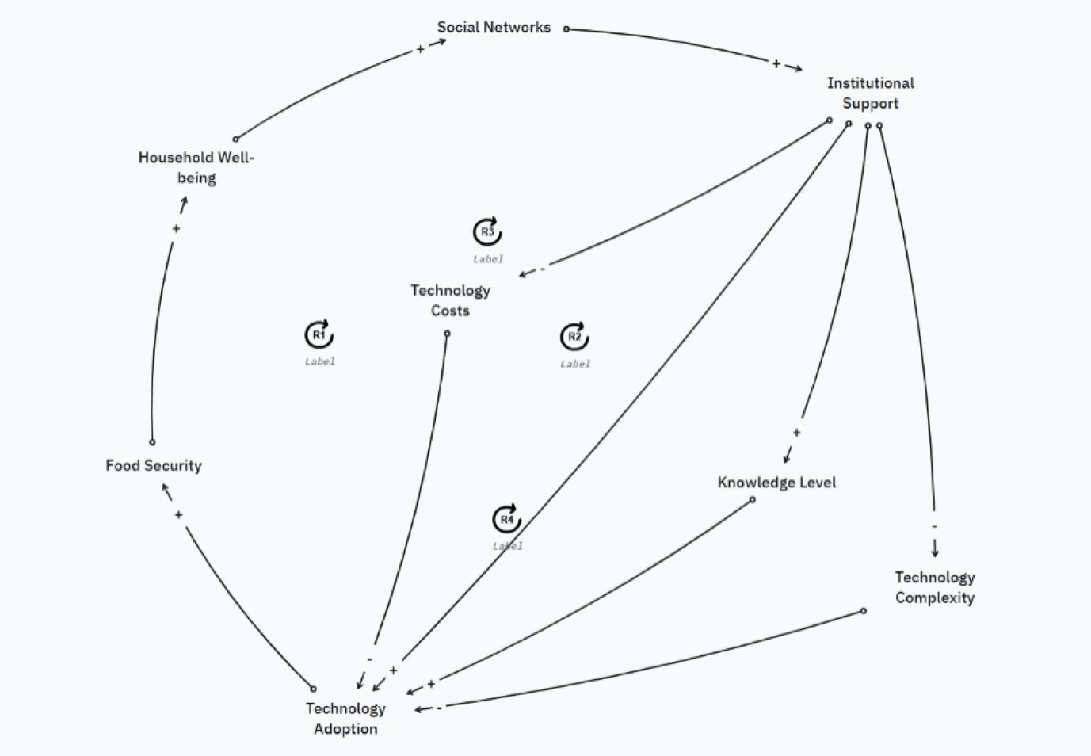

Figure 1: Causal loop diagram using Comodel tool

4.2 Interrelationships among Critical Factors that Influence Technology Adoption in Agricultural Settings (using Comodel)

This causal loop diagram presents the interrelationships among critical factors that influence Technology Adoption in agricultural settings and the broader impacts on household well-being and food security. The system features four major reinforcing loops (R1–R4), each representing a self-reinforcing process that either accelerates or sustains positive change once initiated.

Loop R1: Technology Costs Loop
Technology Costs → Technology Adoption → Food Security → Household Well-being → Social Networks → Institutional Support → Technology Costs
This loop shows how initial technology costs influence the level of technology adoption. Increased adoption improves food security and household well-being, which strengthens social networks. Strong social networks often enhance institutional support (e.g., government programmes, training access), which in turn helps to lower technology costs through subsidies or shared infrastructure—closing the loop.
▶This reinforcing loop suggests that reducing costs at the outset can spark a cycle of improvement that keeps lowering costs over time.

Loop R2: Technology Complexity Loop
Technology Complexity → Technology Adoption → Food Security → Household Well-being → Social Networks → Institutional Support → Technology Complexity
This loop addresses the complexity of new technologies. Initially, high complexity can reduce adoption. However, once adoption occurs and generates positive outcomes (food security, well-being, stronger networks), institutional support tends to grow. Such support often simplifies technologies through training, technical aid, or redesign—reducing perceived complexity.
▶This loop reinforces the value of adoption by decreasing long-term barriers through institutional involvement.

Loop R3: Institutional Support Loop
Institutional Support → Technology Adoption → Food Security → Household Well-being → Social Networks → Institutional Support
This is a direct reinforcing loop where institutional support (e.g., policy frameworks and extension services) fosters technology adoption, improving food security and household well-being. These outcomes reinforce social networks, which in turn feed back into more robust institutional support (e.g., more grassroots advocacy and programme participation).
▶This loop highlights the feedback between community outcomes and institutional engagement, showing how success can build further support.

Loop R4: Knowledge Level Loop
Knowledge Level → Technology Adoption → Food Security → Household Well-being → Social Networks → Institutional Support → Knowledge Level
Here, knowledge or awareness of the technology is the entry point. Increased knowledge boosts adoption, generating better food and well-being outcomes, strengthening networks and drawing in institutional backing. This institutional support then further improves knowledge dissemination via education, outreach, or local champions.
▶This loop shows how investing in knowledge early triggers a continuous learning and improvement cycle.

Reinforcing Pathways to Agricultural Transformation

Together, these loops illustrate a resilient system where improvements in adoption, food security, and institutional support reinforce each other. Strategic interventions—such as reducing costs, simplifying technology, increasing awareness, or strengthening institutional frameworks can set off a cascade of reinforcing effects that drive sustainable agricultural transformation.

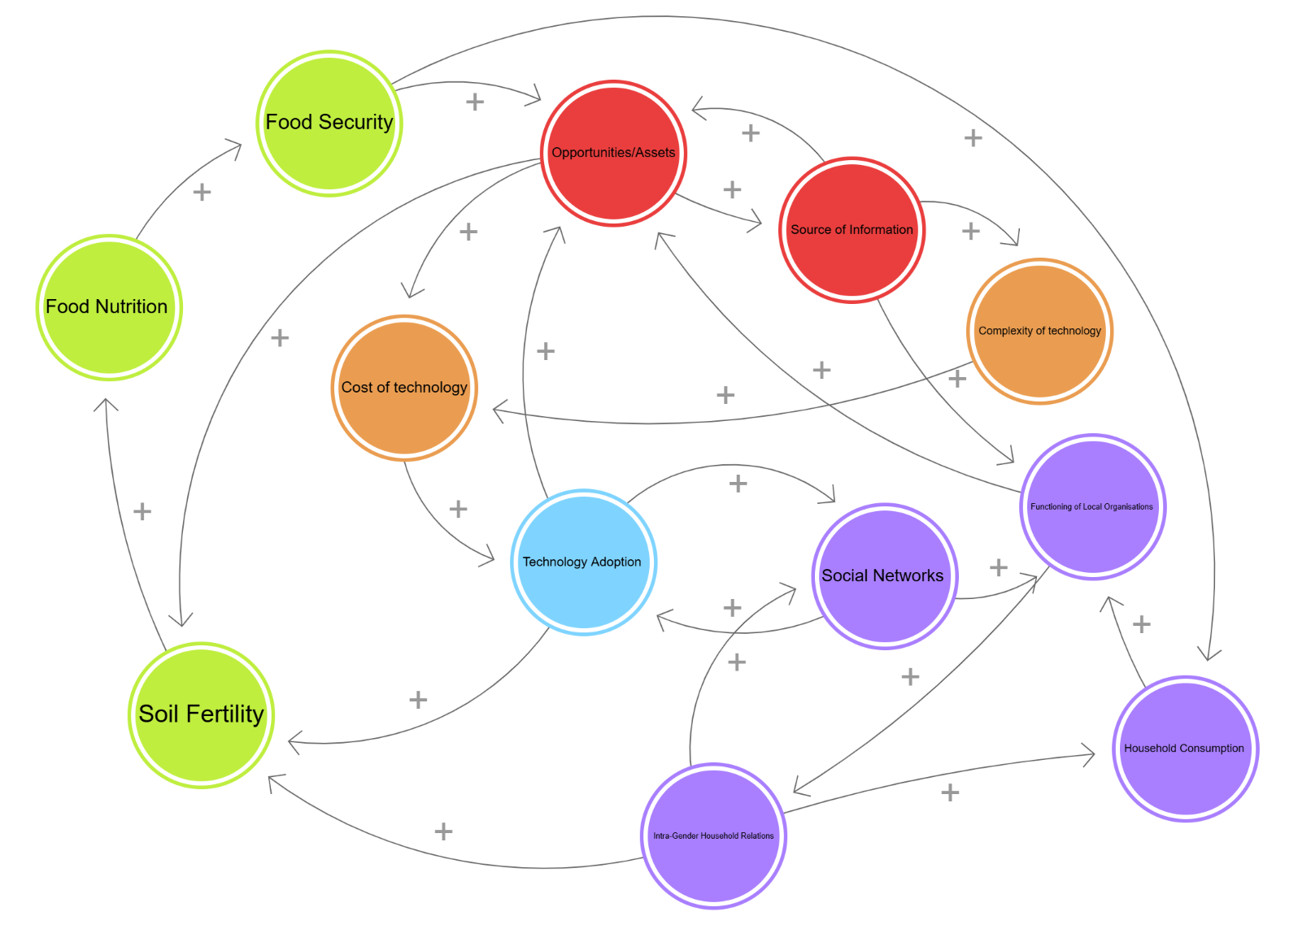

Figure 2: Causal loop diagram using Loopy tool (https://tinyurl.com/mur32s24)

4.3 Dynamic Relationships among Key Variables that Influence Adoption (Results from Causal loop using Loopy Tool)

The causal loop diagram illustrates the dynamic relationships among key variables that influence the adoption and impact of soybean-based technologies within agricultural communities. At the core of the system is Technology Adoption, which serves as the central driver of change and triggers multiple interconnected outcomes.

Positive Feedback Loops
The diagram contains several reinforcing (positive) feedback loops, indicating that improvements in one area tend to generate further benefits across the system:

- Technology Adoption → Soil Fertility → Food Nutrition → Food Security → Opportunities/Assets → Source of Information → Complexity of Technology → Cost of Technology → Technology Adoption
- Adoption of improved technologies (such as better seeds, fertilizer management, and irrigation or conservation practices) enhances soil fertility and crop yields. This increases house hold nutrition and food security, then enhances assets (savings, livestock’s, tools), which can lead to increased source of information giving exposure to better understanding of new technology and how to acquire or build such technologies at reduced cost.
- Opportunities/Assets → Cost of Technology → Technology Adoption → Social Networks → Functioning of Local Organisations → Intra-Gender Household Relations → Soil Fertility → Food Nutrition → Food Security → Opportunities/Assets
- Strong assets reduce financial barriers to adoption. Adoption, in turn fosters knowledge sharing through social networks, which strengthens local organisations (e.g. cooperatives, famers’ associations). These organisations promote fairer intra-households relations and collective resource management, which improve farming outcomes and food security, feed back into more assets.
- Soil Fertility → Food Nutrition → Food Security → Opportunities/Assets → Soil Fertility
- Healthy soil leads to better harvests and nutrition. Stronger food security allows households to reinvest in land and resources, maintaining or improving soil fertility.
- Social Networks → Functioning of Local Organisations → Intra-Gender Household Relations → Social Networks
- Better social networks build effective organisations. These in turn improve equity and collaboration within households, further strengthening community networks and collective action capacity.
- Intra-Gender Household Relations → Household Consumption → Functioning of Local Organisations → Intra-Gender Household Relations
- Improved household relations raise consumption, which empowers local organisations that then feed back into better intra-household relations.
- Food Security → Opportunities/Assets → Cost of Technology → Technology Adoption → Soil Fertility → Food Nutrition → Food Security
- Food security builds assets and can create opportunities which reduces barriers to technology adoption. Adoption improves soil fertility and yields, raising nutrition and food security in a reinforcing cycle.
- Source of Information → Functioning of Local Organisations → Opportunities/Assets → Source of Information
- Access to information strengthens organisations, enabling them to expand their assets and mobilise those resources. Which improves access to even more knowledge and innovation.

Supporting and Moderating Factors

- Opportunities/Assets (e.g., natural, human, and financial capital) play a crucial role in enabling adoption by reducing constraints and boosting resource availability.
- Sources of Information provide the knowledge needed to facilitate adoption and utilisation, positively influencing both assets and understanding of technology.
- Complexity of Technology and Cost of Technology can act as barriers to technology adoption. However, in this system, they are managed through improved information access and social support systems, ultimately having a net positive influence on adoption.

Systemic Impact

The diagram shows how the adoption of soybean technologies generates a ripple effect across household welfare (e.g. food and gender equity), community functioning (social networks and local organisations), and the agricultural environment (soil fertility and food security). These outcomes, in turn, create conditions that reinforce further adoption, forming a virtuous cycle of development and sustainability.

4.4 Inter-relationships among the Variables and Implications using Comodel and Loopy Tool

Drawing from the application of systems thinking and system dynamics in agricultural program impact assessment, the following results implied that:
- Integrate Socio-Economic and Gender Aspects: Future agricultural programs and their assessments must explicitly include socio-economic factors (e.g., household well-being, social capital) and gender dynamics to ensure interventions are equitable and appropriate.
- Embrace Participatory Methods: Moving beyond technocratic approaches, programs should adopt participatory methods throughout their lifecycle, engaging farmers and communities to enhance legitimacy and effectiveness.
- Utilise System Dynamics for Planning: Policymakers should use system dynamics modelling to simulate scenarios and test policies, allowing for proactive governance, identifying leverage points, and mitigating unforeseen consequences.
- Build Capacity in Systems Approaches: Investment in training for agricultural professionals in systems thinking and system dynamics is crucial to equip them with tools for managing complex agricultural systems.
- Develop Adaptive Management: Agricultural programs should be designed for continuous learning and adjustment, using systems thinking as a foundation for frameworks that can evolve with changing conditions.
- Foster Interdisciplinary Collaboration: Encouraging teamwork across natural sciences, social sciences, and economics will lead to more integrated and effective solutions for agriculture's multifaceted challenges.

Conclusion

Agriculture faces increasingly complex challenges, highlighting the limits of traditional planning. This paper has demonstrated the significant value of integrating systems thinking and system dynamics into agricultural program impact assessment.
Systems thinking offers a holistic view of interconnectedness and feedback loops, while system dynamics provides a rigorous, simulation-based method for exploring policy interactions over time. The analysis revealed gaps in existing methods, particularly concerning socio-economic, gender, and participatory aspects. The findings confirm that this integrated approach shifts planning from reactive to proactive, improving our ability to manage uncertainty and complexity, and fostering more sustainable agricultural systems.
In essence, the future success of agricultural development relies on adopting systemic methods that embrace complexity, inclusivity, and sustainability. By systematically incorporating socio-economic and gender-sensitive dimensions, alongside strong participatory approaches, future agricultural program design and assessment can create comprehensive frameworks that accurately reflect and effectively respond to real-world complexities, ultimately contributing to long-term food security and improved household well-being.

References
Alston, J. M., & Pardey, P. G. (2014). Agriculture in the global economy. Journal of Economic Perspectives, 28(1), 121–146. https://doi.org/10.1257/jep.28.1.121
Amissah, M., Gannon, T., & Monat, J. (2020). What is systems thinking? Systems, 8(1), 6. https://doi.org/10.3390/systems8010006
Coulibaly, T. P., Du, J., Diakité, D., Abban, O. J., & Kouakou, E. (2021). A proposed conceptual framework on the adoption of sustainable agricultural practices: The role of network contact frequency and institutional trust. Sustainability, 13(4), 2206. https://doi.org/10.3390/su13042206
Food and Agriculture Organisation of the United Nations. (2017). The future of food and agriculture: Trends and challenges. FAO. https://openknowledge.fao.org/server/api/core/bitstreams/8a7dd930-961f-4855-9952-74a7c221af7b/content
Grewal, B., Grunfeld, H., & Sheehan, P. (2012). The contribution of agricultural growth to poverty reduction. Australian Centre for International Agricultural Research (ACIAR).
Intergovernmental Panel on Climate Change. (2019). Climate change and land: An IPCC special report on climate change, desertification, land degradation, sustainable land management, food security, and greenhouse gas fluxes in terrestrial ecosystems (SRCCL). https://www.ipcc.ch/site/assets/uploads/2019/11/SRCCL-Full-Report-Compiled-191128.pdf
Junankar, P. N. R. (2016). Development economics: The role of agriculture in development. Palgrave Macmillan.
Luft, J. A., Jeong, S., Idsardi, R., & Gardner, G. (2022). Literature reviews, theoretical frameworks, and conceptual frameworks: An introduction for new biology education researchers. CBE—Life Sciences Education, 21(3), rm33. https://doi.org/10.1187/cbe.21-11-0279
Olabisi, L. S., Elegbede, O., & Raven, M. (2020). Insights for farmer training programs from system dynamics: A case study from Northern Michigan. Advancements in Agricultural Development, 1(2), 1–11.
Phan, T., Bertone, E., & Stewart, R. (2021). Critical review of system dynamics modelling applications for water resources planning and management. Cleaner Environmental Systems, 2, 100031. https://doi.org/10.1016/j.cesys.2021.100031
Puspitasari, R., Nurmalina, R., Hariyadi, H., & Agustian, A. (2024). Systems thinking in sustainable agriculture development: A case study of garlic production in Indonesia. Frontiers in Sustainable Food Systems, 8.
Schiere, J. B., Groenland, R., Vlug, A., & van Keulen, H. (2004). Systems thinking in agriculture: An overview. In Emerging Challenges for Farming Systems (Chapter 4).
Sherwood, D. (2002). Seeing the forest for the trees: A manager’s guide to applying systems thinking. Nicholas Brealey Publishing.
Turner, B. L., Menendez, H. M., Gates, R. N., Tedeschi, L. O., & Atzori, A. S. (2016). System dynamics modelling for agricultural and natural resource management issues: Review of some past cases and forecasting future roles. Resources, 5(4), 40. https://doi.org/10.3390/resources5040040
Wakawa, A. M. (2010). Impact assessment framework of soybean-based technologies. In Dynamics in Agricultural Extension Programme Planning, Monitoring and Evaluation (p. 356).
Wakawa, R. C. (2016). Conceptual framework of impact assessment of agricultural programmes. In B. O. Ogunbameru, M. M. Gwary, & Y. L. Idrisa (Eds.), Dynamics of agricultural extension programme planning, monitoring and evaluation (pp. 237–244). Dibal_Sauki Ventures.
Zhang, Z., Eddy, W. C., Stuchiner, E. R., DeLucia, E. H., & Yang, W. H. (2024). A conceptual model explaining spatial variation in soil nitrous oxide emissions in agricultural fields. Communications Earth & Environment, 5, 730. https://doi.org/10.1038/s43247-024-01107-5

Declaration
The authors acknowledged the use of Comodel [https://comodel.io/] and Chat GPT [https://chatgpt.com/] to generate the Causal loop diagram in Figure 1.
The following prompts were performed: “Please generate a causal loop diagram on the topic ‘Application of System Dynamics and Systems Thinking to Conceptual Frameworks for Impact Assessment of Agricultural Programs’ with these variables: Technology Costs, Technology Adoption, Food Security, Household Well-being, Social Networks, and Institutional Support.”
The output helped in attaining a deeper understanding of the topic and showed how system dynamics and system thinking can be applied in assessments of agricultural programs.

